**Coffin Race Rules and Regulations**

1. **Build the coffin:** You can make your coffin out of anything, except, no sharp objects… and bonus praise for using recycled material!
2. **Select your team:** Select your team: Gather the best of the best (4 people total, 18 and over) and your most creative Halloween team costume. If you add a skeleton or character in the coffin, just make sure they secured. Participants are encouraged to wear protective gear, knee guards and helmets.
3. **Win Prizes:** We will have three prizes: 1st and 2nd place in the coffin race, and the final prize goes to the best costume/decorated coffin. Prizes will be announced at a later date.
4. **Be on time:**
   1. 1:30PM: Coffin inspection
   2. 2:15PM: Course walk though
   3. 3:00PM: Race

**RULES:**

1. **NO ALCOHOL OR DRUGS**
2. Stay in your lane – any aggressive driving will lead to disqualification
3. Hands on the handle bars AT ALL TIMES
4. Your team of 4 must safely push your coffin through 500 feet of obstacles with skeletons, aliens, monsters and the unknown to reach the final resting place – the finish line!
5. Two teams at a time will relay, the time will be recorded and the best two times will be the winners, 1st and 2nd place respectively.
6. **This is a competition but it’s also fun, so let’s have a good time with it!**

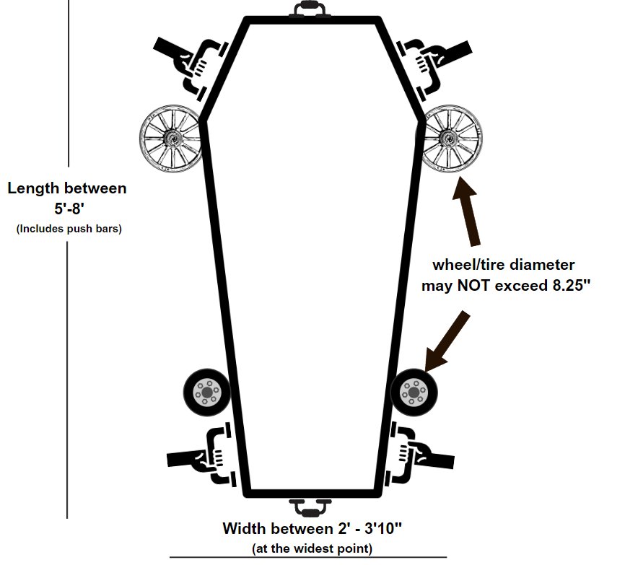

**SPECS:**

1. There are no height restrictions for coffins, however, if there is a large decoration, it will need to come down before the race
2. Maximum width: 3’10”
3. Minimum width: 2’
4. Maximum length: 8’
5. Minimum length: 5’
6. All measurements include wheel base and handle bars
7. Wheels/Tires cannot exceed 8.25” and must be firmly attached.
8. 4 push bars must be firmly attached to coffin, two on either side. Two optional push bars in front and back can also be attached.
9. NO functional steering wheels allowed
10. HAVE FUN!